CMPS 455 / Dr. Kumar
Paging: How program is stored and accessed at the time of execution

Hard Disk
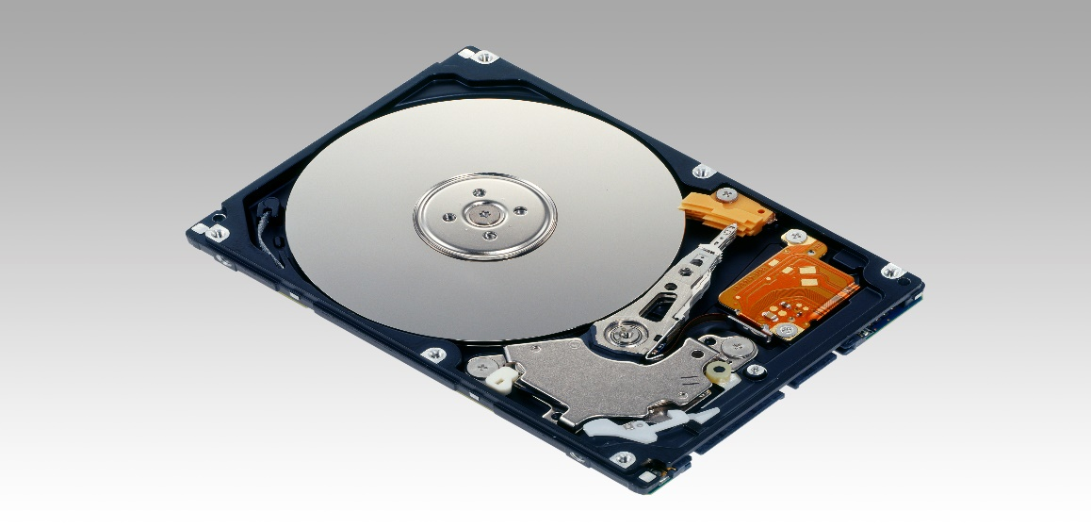

Main Memory
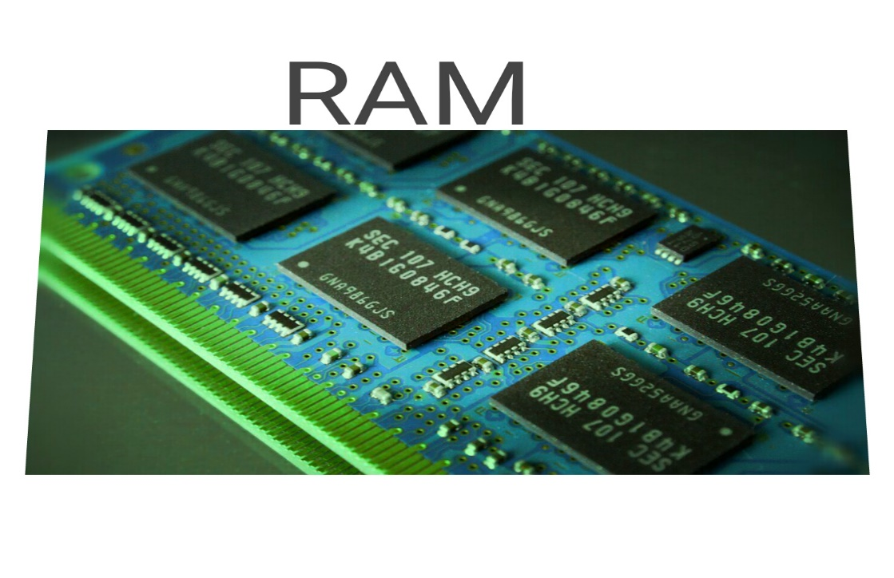

Source of images: Google images
Main Memory or Physical Memory

  address | contents
  contents
Virtual Memory

Virtual memory is not truly any kind of memory. Neither it is hard disk, nor it is main memory, nor it is any type of memory that we can see or touch. Rather, it is a collection of virtual addresses pertaining to program and data.

Virtual Address
These are addresses created by the CPU at the execution time. Virtual addresses are not real addresses. Virtual addresses are not addresses on the hard disk, nor they are addresses in main memory, nor they are addresses in the cache.
CPU thinks that a program’s executable code is contained in
Virtual Address is just address, no contents!
address

So, what happens?
CPU executes a program instruction by instruction. For each instruction that it needs (think of instruction fetch), it generates a virtual address. The virtual address generated so by the CPU is translated into memory address by the operating system (OS). It is the OS that knows where contents are stored in the main memory.

Paging
Idea: Divide virtual address space and main memory (or physical address space) into equal sized chunks so that there is enough flexibility to bring over (copy) any chunk from virtual memory into any available chunk in the main memory. The chunks in the main memory are called frames, whereas the chunks in virtual address space are called pages.

Let’s learn with a few examples next.

EXAMPLE 1
A virtual address space with each page consisting of two instructions (note: I denotes instruction)
Page 1
Page 8
Page 7
Page 6
Page 5
Page 4
Page 3
Page 2
Page 0
I0
I1
I2
I3
I4
I5
I6
I7
I8
I9
I10
I11
I12
I13
I14
I15
I16
I17

Offset within a page:
Offsets within a page are 0 and 1 in this example

EXAMPLE 2
A virtual address space with each page consisting of four instructions (note: I denotes instruction)
Page 4
Offsets for I16, and I17 are 00, and 0, respectively.
This page is partially filled and has internal fragmentation. This is the last page in this example.

Page 3
Offsets for I12, I13, I4, and I15 are 00, 01, 10, and 11, respectively.

Page 2
Offsets for I8, I9, I0, and I11 are 00, 01, 10, and 11, respectively.

Page 1
Offsets for I4, I5, I6, and I7 are 00, 01, 02, and 03, respectively.

Page 0
Offsets for I0, I1, I2, and I3 are 00, 01, 10, and 11, respectively.

I0
I1
I2
I3
I4
I5
I6
I7
I8
I9
I10
I11
I12
I13
I14
I15
I16
I17

Example 3
A virtual address space with each page consisting of eight instructions (note: I denotes instruction)
Page 2
Offsets for instructions
I16 : 000

Page 2 is the last page and it is partially filled. It has internal fragmentation

Page 1
Offsets for instructions
I8 : 000
I9 : 001
I10 : 010
I11: 011
I12 : 100
I13 : 101
I14: 110
I15: 111

Page 0
Offsets for instructions
I0 : 000
I1 : 001
I2 : 010
I3 : 011
I4 : 100
I5 : 101
I6 : 110
I7 : 111

I0
I1
I2
I3
I4
I5
I6
I7
I8
I9
I10
I11
I12
I13
I14
I15
I16
I17

So, what happens next in paging?

- A page is copied into an available frame in the main memory (or physical address space)
- There is no need to translate offsets because the relative location of an instruction inside of a chunk (i.e., page or frame) remains unchanged – because the size of a page is equal to the size of a frame.
- The page table is updated to reflect which page is in which frame.

What does a page table and address translation look like (in linear paging) ?

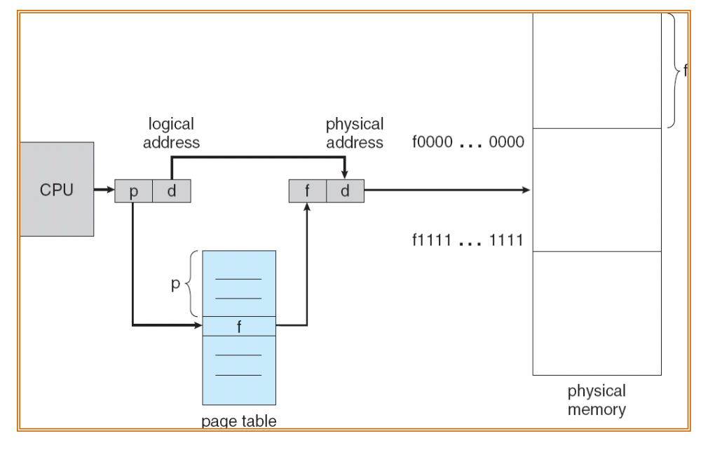

Linear Page Table (copyright: Alvin Lebeck)

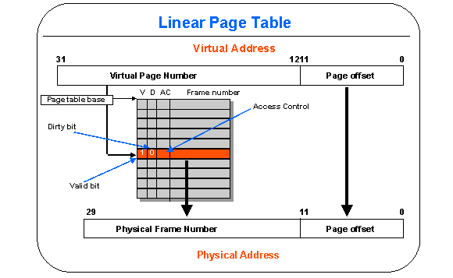

Recap: Address Translation in Linear Paging

Limitations of linear paging and the need for a better paging method
discuss

Two Level Paging / Two Level Page Table
Instead of one page table, there are several page tables. They are organized at two levels, and hence the name.

Addressing for Two Level Paging
Three Level Paging / Three Level Page Table

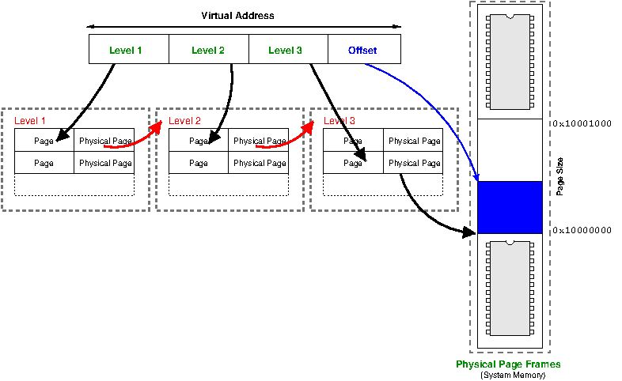

Addressing for Three Level Paging

Inverted Paging / Inverted Page Table

